BES(T)POKE

Software Development Plan

Berk Mertoğlu
Atakan Coşar
Zeynep Durmuş
Aslı ARAS
Ata Barış Kuğu
Berkay KOÇ
Eralp Çolakoğlu
Arzum Naz Güney

17.05.2026

Contents
Contents 1
1. Overview 1
2. High-Level Functionality 1
3. Software Tools 1
4. Software Process Model 1
5. Schedule and Effort 1
6. Stakeholders and Project Risks 2
7. Measurements 2
8. Graphical User Interfaces 2
9. Conclusion 2

1.0 Overview

1.1 Problem Definition
Many freelance creators (artists, developers, etc.) and clients face severe communication breakdowns, trust issues, and discoverability challenges in custom commission processes. Vague client requests often lead to repeating conversations that lead to nowhere. Additionally, new creators struggle to gain visibility on traditional platforms. Furthermore, the lack of a secure and universal payment ecosystem exposes both parties to fraud, such as catfishing or unpaid labor, making the freelance ecosystem unreliable.

1.2 Background Information
Commissions are formal requests where a client hires a creator to make a custom, one-of-a-kind piece of artwork or product based on specific requirements. The creator economy relies heavily on custom commissions, yet the current workflow is highly fragmented. Creators typically use multiple social media platforms for visibility and to negotiate requirements, and external links for payments. This disjointed approach creates an environment prone to misunderstandings and scams, as none of these platforms offer security for the entirety of the process.
To start with, due to the disjointed approach content creators currently use in case of a scam or other issues that happen during the entire process can not be pinned down to one platform. For example, if a creator uses fake ai images for advertisement in a social media platform but takes payment with a different platform, the buyer cannot demand from any of the two platforms to hold the creator accountable for the scam. Because technically none of the two platforms policies were violated. Another issue is with the vague requests from clients who lack the knowledge to give proper information about their order. As a result, creators are forced to ask or answer the same questions to different clients over and over again, which often leads to misunderstandings and even the client deciding not to place the order. Lastly, using external links for payments can get messy if the client and the creator can not agree on which platform to make the transaction on. Common tools used for transactions by the community in some countries are often unavailable in others, which makes international commissions hard to deal with.
A unified platform that combines a secure social discovery feed, structured order forms that can be customized by the seller, and an escrow-based payment system is essential. By standardizing the request process and securing funds, the platform can eliminate communication chaos and build a trust-based ecosystem for creators.

1.3 Objectives
Trust & Transparency: To provide a trustworthy environment for creators and clients by eliminating fraud and unauthorized AI usage.
Communication Efficiency: To reduce communication complexity by replacing informal, fragmented negotiations with a structured, form-based ordering system.
Creator Discoverability: To improve creator discoverability beyond generic, fragmented social media searches.
Financial Security: To ensure complete financial security for all parties involved in commission transactions.
Scalability: To deliver a robust and scalable platform capable of supporting a growing creator economy.
Advanced Filtering: To implement a structured filtering system using specific creator attributes to achieve faster

2.0 High-Level Functionality

2.1 Functional Requirements
,one detailed paragraph for each requirement
REQ. # | Requirement Title | Description
FR-1 | User Registration & Role RBAC | The system must allow users to register with email verification and select either a Creator or Client role. Upon selection, the system must automatically assign a Role-Based Access Control (RBAC) permission set:  • Creators: Access to portfolio management, order form creation, and commission handling tools.  • Clients: Access to discovery, ordering, and payment features.
FR-2 | Profile Management | Creators must be able to build public profiles featuring portfolios, pricing, and expertise tags. The system must block the profile from becoming publicly visible until a minimum of 3 expertise tags are configured.
FR-3 | Customizable Order Forms | The system must support creator-defined order forms supporting five field types: text input, multiple choice, checkbox, dropdown list, and file upload.
FR-4 | Commission Workflow Tracking | The system must provide structured status tracking from submission to final delivery. Creators must define a maximum revision limit per order during form creation. When this limit is reached, the system must block further revision requests and present the client with two options: accept the current delivery, or request an additional revision at an extra fee set by the creator.
FR-5 | Escrow Payment Automations | Client funds must be captured and held in a secure escrow system upon order acceptance. The system must release payment to the creator only when:  (a) The client explicitly approves the final delivery  OR  (b) 72 hours pass after the delivery is marked as completed with no dispute raised by the client.
FR-6 | Integrated Messaging System | The system must feature an integrated chat system allowing creators and clients to communicate both pre-sale and throughout the active commission lifecycle directly inside the application interface.
FR-7 | Real-Time Notification Engine | The system must provide a centralized notification engine that automatically dispatches real-time push notifications and alerts to users for critical events, including order status updates, new messages, and escrow financial actions.
FR-8 | Advanced Discovery Engine | The system must provide an attribute-based search and filtering engine allowing clients to discover creators by style, cathegory, price range, availability, and expertise tags.
FR-9 | Double-Blind Rating System | The system must support a two-way review and rating workflow upon order completion. Reviews/ratings shall remain hidden and only become publicly visible on profiles when both parties have submitted their review, or after 7 days have passed since order completion, whichever comes first.
FR-10 | Dispute Resolution Workflow | The system must provide a structured moderator-led conflict resolution process. When a dispute is triggered, the system must automatically:  (a) Freeze escrowed funds,  (b) Notify both parties and an assigned moderator,  (c) Open an evidence-submission window, and  (d) Allow the moderator to execute a full/partial refund or full release.

2.2 Non-Functional Requirements

REQ. # | Requirement Title | Description
NFR-1 | System Scalability | The system must support a minimum of 1,000 concurrent active user sessions while ensuring that at least 95% of standard HTTP requests maintain a response time under 2 seconds.
NFR-2 | System Performance | The system must deliver advanced discovery search results within 3 seconds and dispatch real-time system notifications within 1 second under standard network conditions.
NFR-3 | Data Security & Compliance | The system must enforce end-to-end TLS 1.3 encryption for data in transit, utilize AES-256 encryption for all data at rest, and maintain strict compliance with PCI-DSS standards for all payment transactions.
NFR-4 | Platform Availability | The system must guarantee a 99.9% application uptime calculated on a rolling monthly basis, excluding pre-announced and scheduled maintenance windows.
NFR-5 | Resource Isolation | The system must isolate heavy background tasks—such as large file processing and high-volume notification dispatches—using dedicated background worker threads to prevent user interface latency or blocking exceeding 2 seconds.
NFR-6 | Regulatory Compliance | The system must adhere strictly to GDPR regulations by implementing automated data minimization workflows and providing user-triggered "right to be forgotten" data erasure protocols.
NFR-7 | Interface Usability | The system must provide an intuitive interface that allows first-time users to complete and submit a standard custom order flow in a maximum of 5 distinct actions or clicks without requiring external documentation.
NFR-8 | Cross-Platform Compatibility | The system must deliver an adaptive responsive layout that renders correctly across Google Chrome, Mozilla Firefox, Apple Safari, and Microsoft Edge, ensuring full client-side script execution completes within 3 seconds.
NFR-9 | System Maintainability | The system must utilize a decoupled, modular software architecture ensuring that any future structural component changes or feature enhancements require modifications to less than 20% of the existing core codebase.
NFR-10 | System Auditability | The system must maintain an append-only, immutable transaction database layer that logs all financial transitions and status updates using standardized ISO-8601 timestamps for transparent auditing.

3.0 Software Tools
//tool selection table and one paragraph explaining why a tool is needed and why the specific tool was selected

4.0 Software Process Model

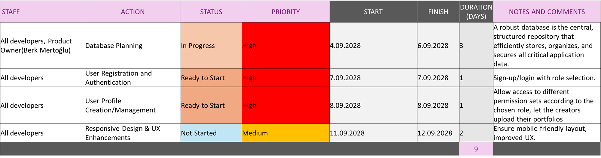

5.0 Schedule and Effort
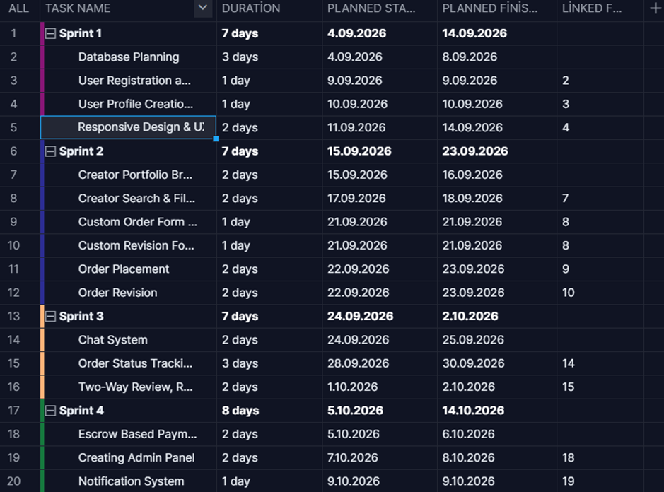

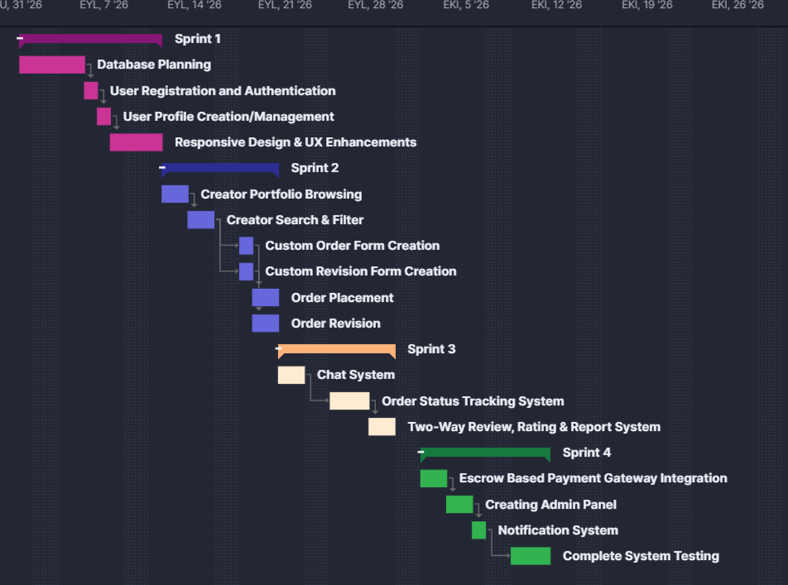

6.0 Stakeholders and Project Risks

6.1 Stakeholders
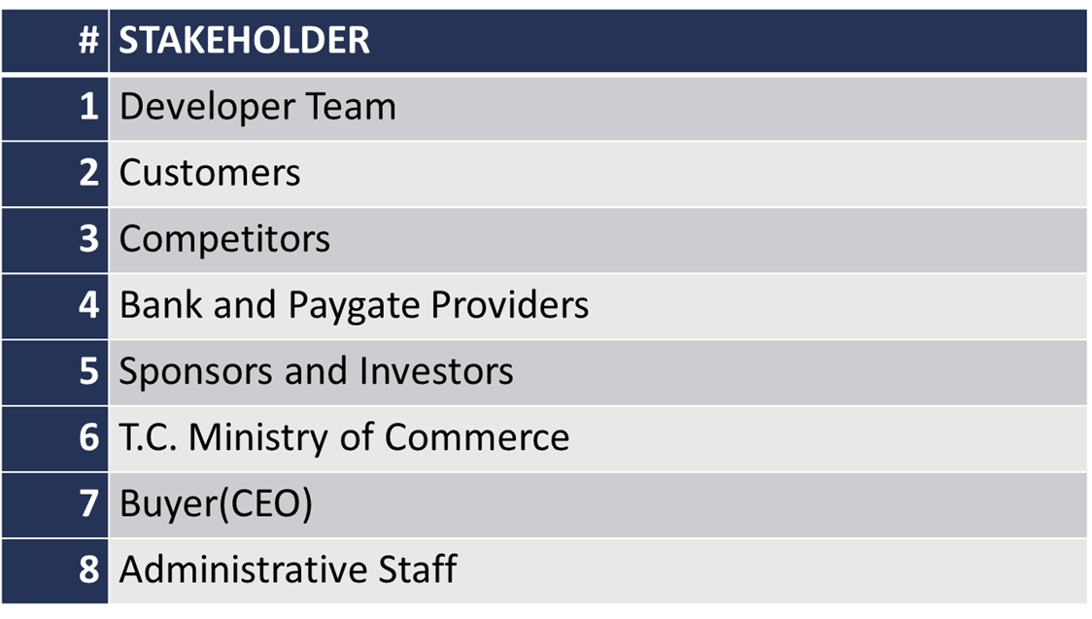
//One paragraph for each stakeholder
Developers write the project code. If the project successful is they will improve their technical skills and gain credibility. If the project fails they will lose credibility in the field.
Customers use the platform to promote their portfolios and to purchase custom orders. If the project is successful they will have a platform that keeps their intellectual property secure and allow them to complete secure transactions. If the project fails they might lose money or have their artwork stolen on the platform.
Competitors push the team to innovate through market competition. If the project is successful the competitors’ market share will be divided. If the project fails they maintain their market dominance.
Banks and paygate providers are the project's source for the infrastructure for secure escrow and financial transfers. If the project ends up a success, they will process high transaction volumes and improve their market reputation.
Sponsors provide the required funding for the project. In case of success they will improve their reputation and get high return on their investment. If the project fails they will lose their financial investment and professional time.
T.C. Ministry of Commerce establishes the legal framework for data privacy and commerce, which affects the structure of the software. The success and failure of the project wouldn’t directly affect the government.
The CEO of the company the platform is bought by defines the core vision and the requirements of the project. If the project results in success they will own a profitable platform and a unique business model. If the project fails they will lose their competitive advantage and the value of their idea.
Administrative Staff moderate the platform and resolve user-submitted disputes. In case of Project success they maintain their positions as the moderaters. If the project fails they will be let go.
6.2 Project Risks
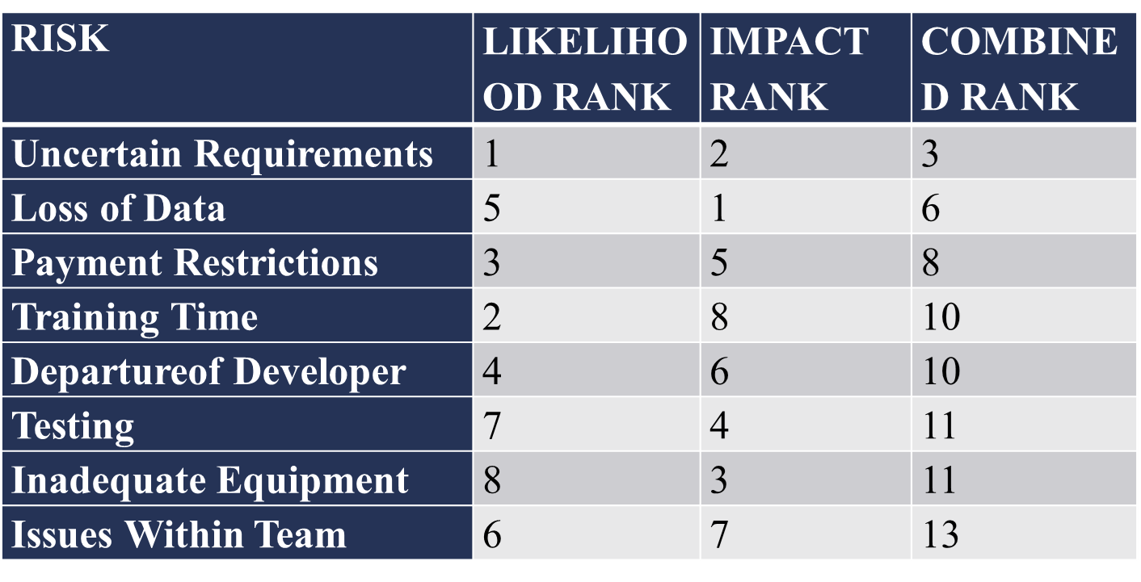
//One paragraph for each risk explaining the risk, reasons for the likelihood and impact rank and the resulted combined rank
Uncertain Requirements: The requirements defined by the buyer may not be clear or change over time.
Loss of Data: Losing crucial progress and data due to uncontrollable external factors.
Payment Restrictions: The withdrawal of payment gateways can eliminate the project's revenue model or block market access in entire regions.
Training Time: The team may be inexperienced with the tools and deployment platform required for the Project and need time for training.
Departure of Developer: Team members leaving the project unexpectedly, causing a loss of critical knowledge and significantly increasing the workload.
Testing: Not being able to test enough cases due to lack of proper data.
Inadequate Equipment: Failure to integrate with key platforms limits the user base and reduces the product's overall value.
Issues Within Team: Productivity levels can be affected by issues that may arise between team

7.0 Measurements
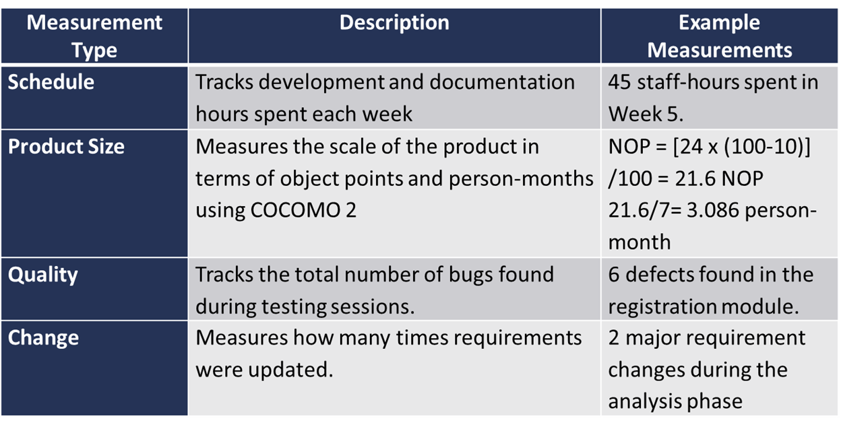
//One paragraph per measurement

8.0 Graphical User Interfaces

9.0 Conclusion
(Write a brief conclusion of the document.)

